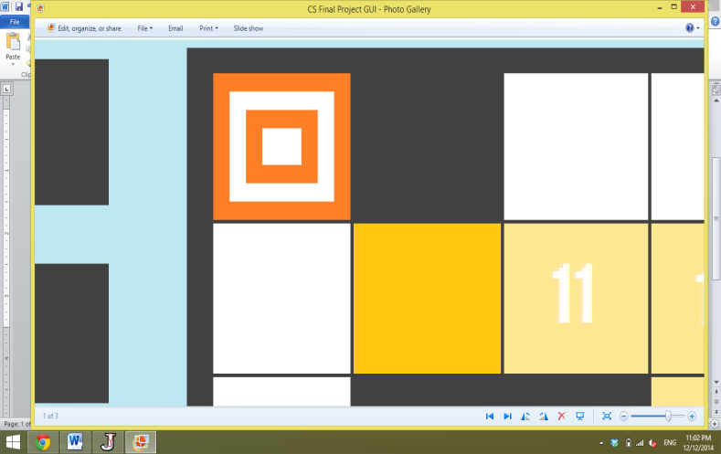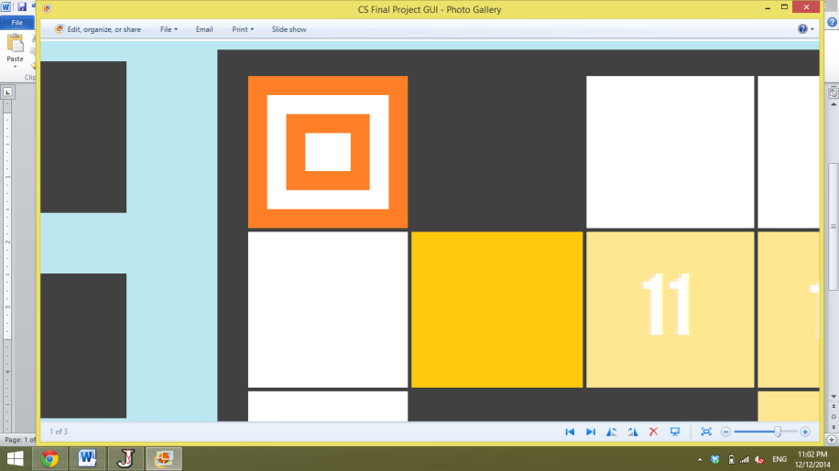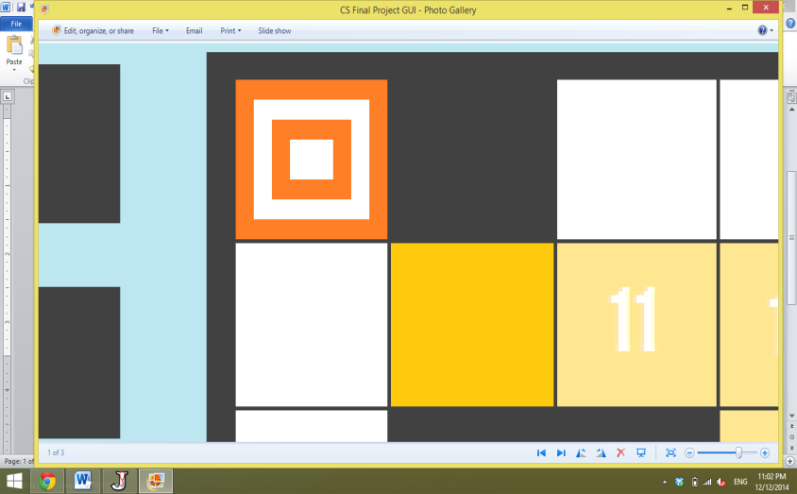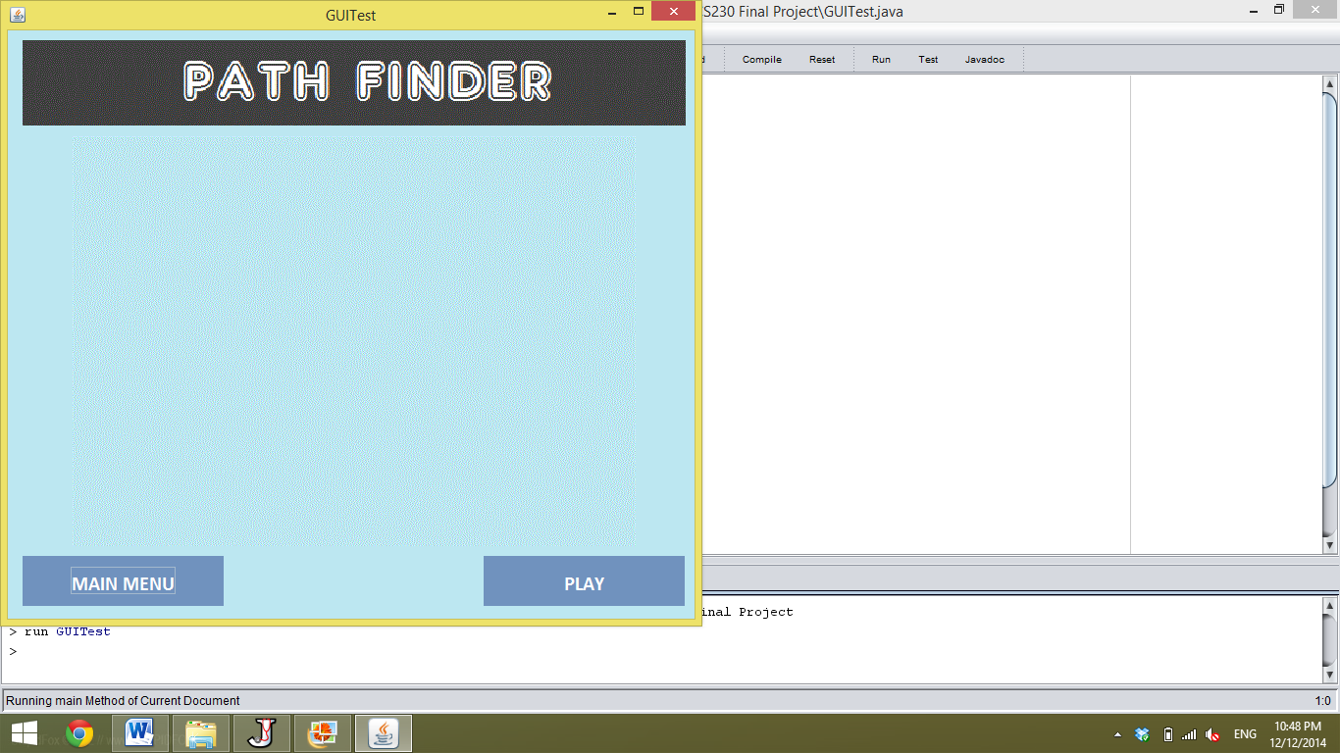

**THE GOAL:** reach your target in the **least** number of steps possible

**THE CONTROLS:** use your **arrow** keys

**THE PLAYERS:**

youtarget block

**IF MULTIPLE TARGETS:** you must visit each and **every target** in **whatever order** you choose

**BUT:** you still must do so in the **least** number of steps possible

**GOOD LUCK:** this is **trickier** than it sounds!

youtarget block



**CONGRATULATIONS!**

**You completed the entire game!**

**TRY PLAYING RANDOM LEVELS!**

**They’re a ton of fun!**

**design by PRISCILLA**

**functionality by AMY & MICHELLE**